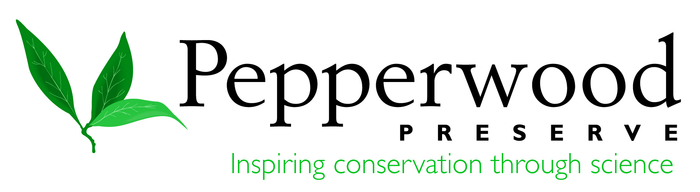

Join us for an introduction to
Citizen Science
in the Elementary Classroom!

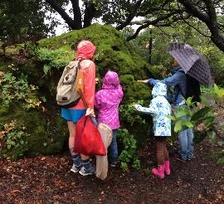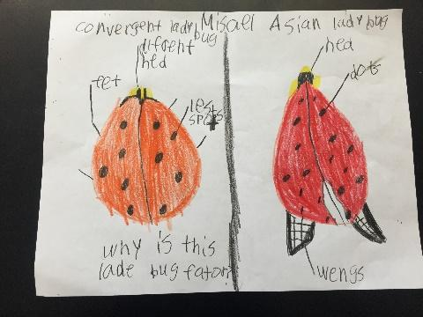

What it is: Learn to integrate citizen science into elementary science classrooms. In citizen science projects, students work with scientists to support data collection, make observations, and contribute to science in the real world.

What we’ll do: You will learn what citizen science is, and how to use it in your classroom. You will engage in activities such as scientific sketching and data collection in the field (weather dependent), and plan for what citizen science can look like in your classroom. We will also discuss how citizen science connects to Next Generation Science Standards (NGSS).

Who: This workshop is open to elementary school teachers, and is offered as a partnership between UC Davis School of Education and Pepperwood Preserve.

Why: Increase engagement with science that extends beyond the classroom walls and connect to the Next Generation Science Standards.

Time: Wednesday, Feb. 15th, 2-5 PM

Location: Dwight Center for Conservation Science, Pepperwood Preserve,
2130 Pepperwood Preserve Road, Santa Rosa, CA 95404

To Register: Sign up at http://citizenscienceworkshop.brownpapertickets.com, or contact
Margaret Boeger at: mboeger@pepperwoodpreserve.org or 707-591-9315 x121

Teachers will receive a $150 stipend to attend.

