Viernes, 9 de febrero del 2018
8:30am- 2:30pm
La Oficina Educativa del Condado de Sonoma (SCOE)

¡GRATIS!
- Presentaciones en Español
- El desayuno y almuerzo incluido también
- Desafortunadamente, NO hay cuidado de niños

Instituto de Liderazgo de Padres

Registro/Preguntas http://www.scoe.org/pub/htdocs/class.html?class_id=6961
Christine Vasquez (707) 524-2816 cvasquez@scoe.org

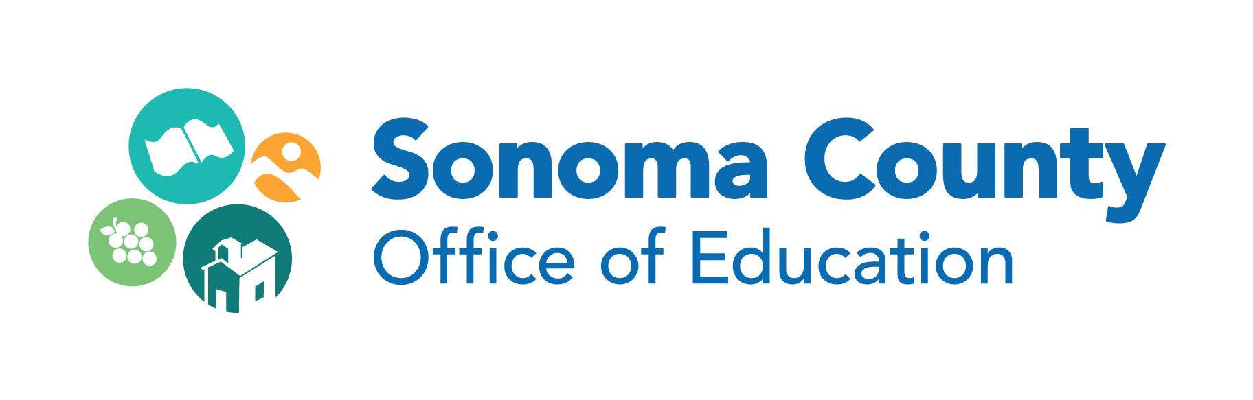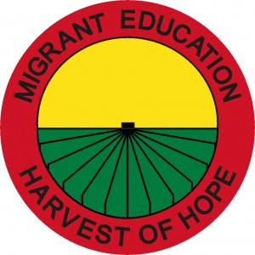
Friday, February 9, 2018
8:30am- 2:30pm
The Sonoma County Office of Education

FREE!
- All presentations conducted in Spanish
- Breakfast and lunch included
- Unfortunately, childcare is not available

English Learner Parent Leadership Institute

Registration/Questions http://www.scoe.org/pub/htdocs/class.html?class_id=6961
Christine Vasquez (707) 524-2816 cvasquez@scoe.org

