The Initial English Language Proficiency Assessments for California (ELPAC) and the California Longitudinal Pupil Achievement Data System (CALPADS)
  - April 21, 2020
Brandi Jauregui
Information Technology Specialist
Education Data Management Division

Traci Albee
English Language Proficiency and Spanish Assessments Office, Administrator
Assessment Development & Administration Division

Computer Based Initial ELPAC Timeline
May 1, 2020: Online training and certification through the Moodle Training Site is available​
June 26, 2020: Last day to enter 2019–2020 Initial ELPAC results into the Local Scoring Tool​
June 27─June 30, 2020: System rollover from 2019–2020 to 2020─2021​
July 1, 2020: Online Initial ELPAC administration window opens​
July 1 through August 19, 2020: Paper-pencil option available
August 20, 2020 through June 30, 2021: Online option available

Initial ELPAC Administration Options

Prior to Testing
Coordinate with your student information system (SIS) administrator to ensure all students who are required to be tested prior to the start of the school year are enrolled in the SIS and in CALPADS.

Paper-Pencil Initial
Local educational agencies that decide to use the paper-pencil Initial ELPAC during the first six weeks must:​
- Administer the paper-pencil Initial ELPAC.
- Submit a list of Statewide Student Identifiers (SSIDs) for each student tested to Educational Testing Services prior to the opening of the online Initial ELPAC on August 20, 2020.
- Enter all student responses/scores into the Data Entry Interface (DEI)

Computer-based Initial
On August 20, 2020 when the Computer-based Initial ELPAC is available, LEAs must:
- Administer the computer-based Initial ELPAC
  - Reading and Listening answers are scored by the Test Delivery System (TDS).
- Record student responses in the TDS and then enter the Speaking scores into the DEI
- Students type their Writing responses into the TDS for grades 3–12 and the Test Examiner score the Writing in the THSS.
- Students respond on the paper-pencil test in grades K-2. Enter grades K–2 writing scores into the DEI

Student Score Reports
Beginning August 20, 2020, once all aspects of the test are complete and scores have been entered into the DEI and THSS or the TDS, scoring will begin.
Upon completion of scoring, the system will produce an official Initial ELPAC Student Score Report (SSR) within 24 hours. SSRs will be available electronically and can be accessed through TOMS.

Data Needed to Take the Initial ELPAC
Prior to testing, LEAs must send the following to CALPADS:
- Student Enrollment Record (SENR) with
  - Primary (10) or Short-Term (30) with the student’s EXPECTED enrollment start date (may be a date in the future)
- Student English Language Acquisition (SELA) record with
  - an English Language Acquisition Status (ELAS) of “TBD”
  - An ELAS start date of the current date
  - A primary language other than English or American Sign Language
- Student Information (SINF) record with associated student profile and student address

After These Data Have Been Entered
Once data are submitted to CALPADS and an SSID is generated, student will appear in TOMS within 48 hours as eligible to take the Initial ELPAC.

If tested between July 1, 2020 and August 19, 2020 (inclusive), LEAs should:
- Test student with paper-pencil Initial ELPAC
- Preliminarily score the test to determine appropriate English language development services, if appropriate
- Retain the preliminary results of the paper-pencil test until the responses/scores can be entered into the Data Entry Interface (DEI) on or after August 20, 2020 to produce the official score to parents

If tested on or after August 20, 2020, LEAs should:
- Test the student with the computer-based Initial ELPAC
- The results will then be used to calculate the student’s official score and ELAS
- The Initial ELAS of English Learner (EL) or Initial Fluent English Proficient (IFEP) will be sent directly from TOMS to CALPADS in a nightly feed and visible to LEAs in CALPADS within 48 hours

Downloading the Initial ELAS into your SIS
Once the Initial ELAS is available in CALPADS, LEAs can download one of the following extracts to import into the SIS:
- SSID Enrollment Extract – contains the student’s most recent ELAS and ELAS Start Date
- SELA Extract – contains all SELA records for enrolled students
CALPADS will then send this status back to TOMS in the nightly student export and will be visible within 48 hours.

ELAS Data Flow
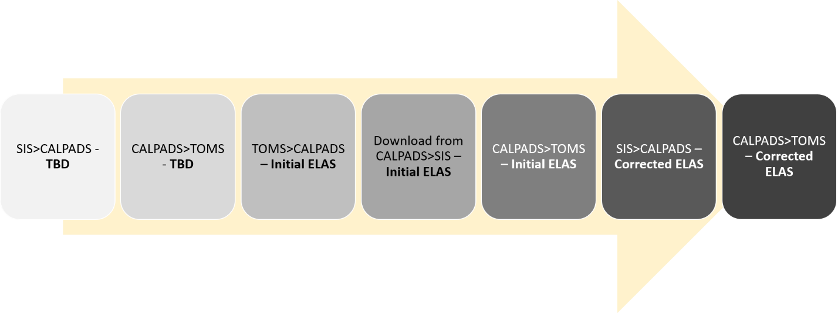

How the ELAS Affects the ELPAC

Scenario #1:
- Student enters LEA
- Home Language Survey (HLS) says English Only (EO)
- ELAS listed as EO
- Student is not given the Initial ELPAC

Scenario #2:
- Student enters LEA
- Home Language Survey (HLS) lists a language other than English
- ELAS listed as TBD
- Student is given the Initial ELPAC
- Initial ELPAC scores the student as Initial Fluent English Proficient (IFEP)
- TOMS updates CALPADS with an ELAS of IFEP
- Student does not take the Summative ELPAC

Scenario #3:
- Student enters LEA
- Home Language Survey (HLS) lists a language other than English
- ELAS listed as TBD
- Student is given the Initial ELPAC
- Initial ELPAC scores the student as English Learner (EL)
- TOMS updates CALPADS with an ELAS of EL
- Student takes the Summative ELPAC

The Initial ELAS
The Initial ELAS and ELAS Start Date (date testing was completed) will be automatically loaded into CALPADS and cannot be deleted or modified by any LEA
If an LEA initiates a correction to the Initial ELAS prior to the administration of the Summative ELPAC, the Initial ELAS can be corrected by the submission of a subsequent record in the CALPADS online maintenance interface with the corrected status and appropriate Correction Reason Code.
Beginning July 1, 2020 (even during paper/pencil administration), statuses of EL or IFEP cannot be submitted by an LEA without a Correction Reason Code if the ELAS start date is after June 30, 2020.

Scenario #1
 | Reporting LEA | ELAS | ELAS Start Date | Effective Start Date | Primary Language | ELAS Correction Reason Code
LEA Submits Correction | ABC Unified | English Only (EO) | 9/30/2020 | 9/30/2020 | English | 1 – Home Language Survey Error
TOMS sends to CALPADS | ABC Unified (system generated not editable) | English Learner (EL) | 8/20/2020 | 8/20/2020 | Spanish
LEA Submits to enable student to test | ABC Unified | To Be Determined (TBD) | 8/18/2020 | 8/18/2020 | Spanish

Scenario #2
 | Reporting LEA | ELAS | ELAS Start Date | Effective Start Date | Primary Language | ELAS Correction Reason Code
LEA Submits Correction | ABC Unified | Initial Fluent English Proficient (IFEP) | 11/30/2020 | 11/30/2020 | Spanish | 2 – Rotating Score Validation Process
TOMS sends to CALPADS | ABC Unified (system generated not editable) | English Learner (EL) | 8/20/2020 | 8/20/2020 | Spanish
LEA Submits to enable student to test | ABC Unified | To Be Determined (TBD) | 8/18/2020 | 8/18/2020 | Spanish

Summative ELPAC Eligibility
Ensure SELA records are updated regularly to update students who have been reclassified. Reclassification can happen at any point in the year when the student meets all of the eligibility criteria. Note: students whose status has not been updated on or before May 31st will be counted as non-testers.
In order to be eligible to take the Summative ELPAC, students must have an ELAS of EL in CALPADS
Student must be < 22 years of age at the time testing is initiated

Accessibility Resources

Students who Require Accessibility Resources
- Students with Disabilities
- Students on a Section 504 Plan
- English Learners
- General Ed Students

Accessibility Resources
In the 2021─2022 academic year the California Department of Education (CDE) is planning to collect all accessibility resources (accommodations and designated supports) for all students in CALPADS which will then be funneled directly to Test Operations Management System (TOMS).

In preparation for this change LEAs must:
- Identify where test settings for different student groups (especially for English learner [EL] students) are currently maintained and identify who is responsible for maintaining those test settings and in what system;
- Develop local processes for identifying, inputting and maintaining test settings for all students in their special education data system (SEDS) and SIS; and
- Develop a timeline to ensure all test settings for students are in place and input into local systems at least two weeks prior to testing.

Where Resources are Currently Tracked:
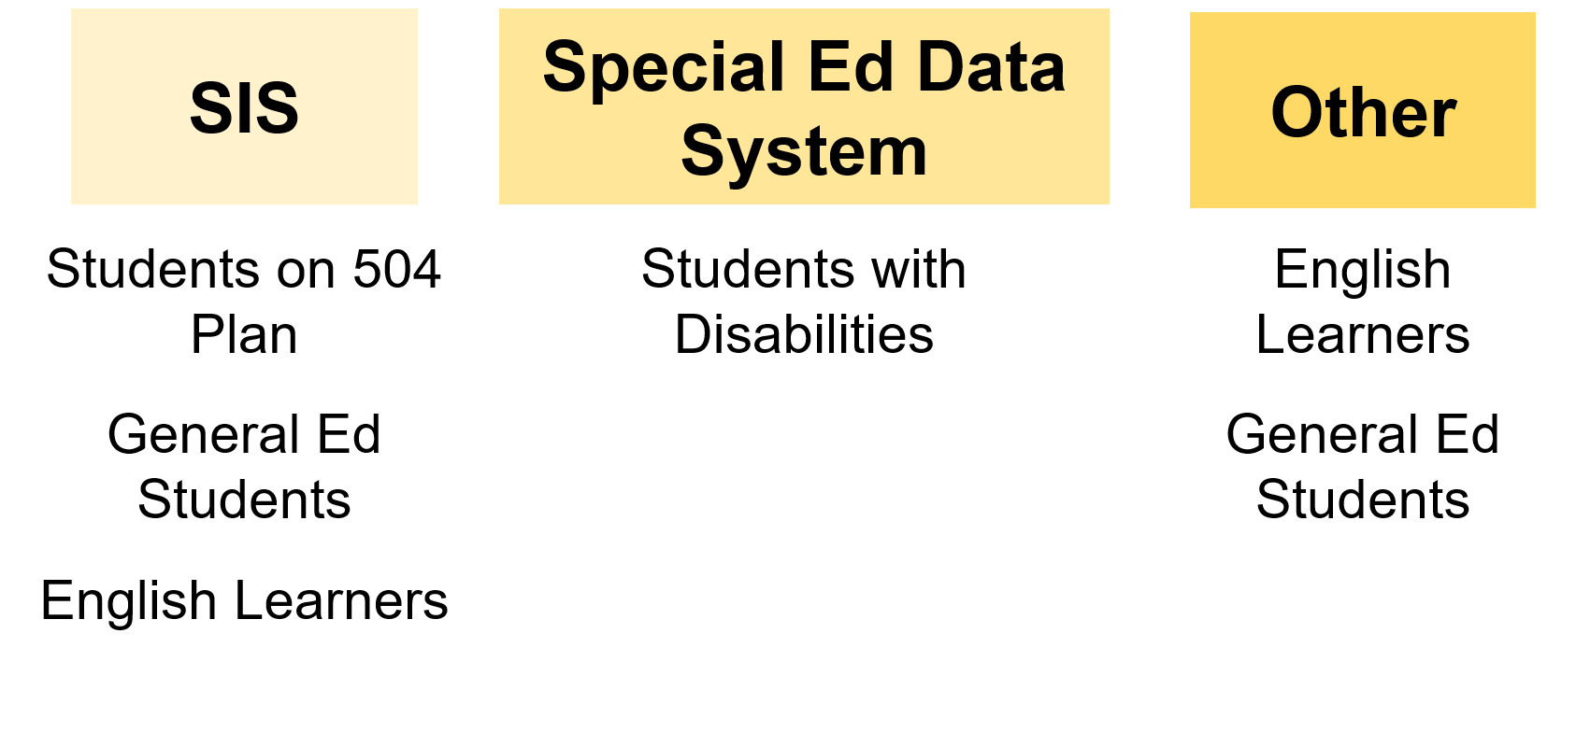

Where Resources NEED to be Tracked in 2020–21:
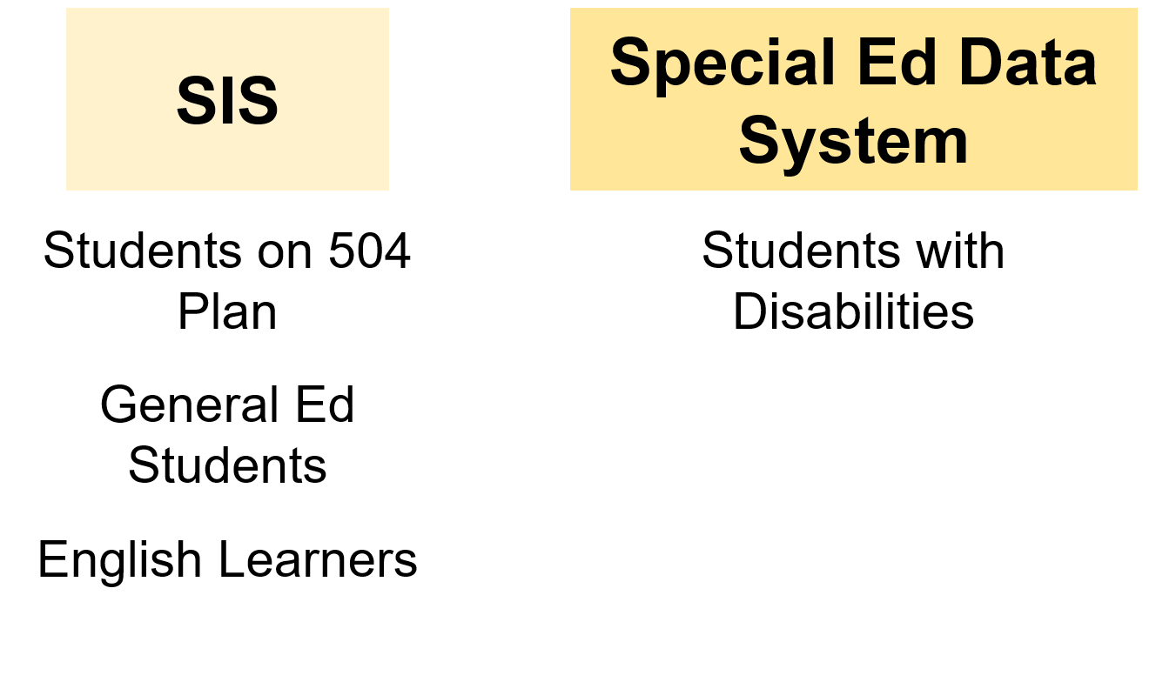

Question and Answer

Further Questions
For ELPAC, send an email to elpac@cde.ca.gov
For CALPADS, send an email to calpads@cde.ca.gov
Follow the Assessment Division on Twitter!
@CDEassessments
California Department of Education—June 2020

